Please ensure fees for all sessions for the following month are paid in advance.

Unity Trust Bank

Account Name - Single Point Plus Limited

Account Number - 20415183

Sort code 60-83-01

**Our new location is;**

**31 Church Street,**

**Oldbury**

**B69 3AG**

(Opposite the Big House).

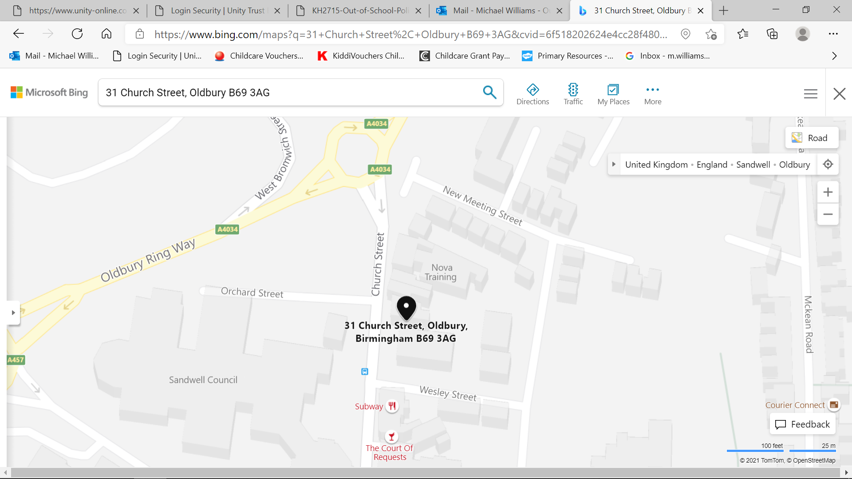

We have parking for parents when collecting.